Calculation of the one-sided SAFE dimensionless conductance,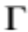
Step 1. To standardize the procedure is estimated first when the distance where the head on the right and left sides of the river banks is assumed to be the standard far distance 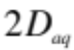 assuming isotropy and no penetration of the river into the aquifer. This is referred to as flat isotropic with symbol 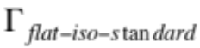. The formula derived analytically exactly is:
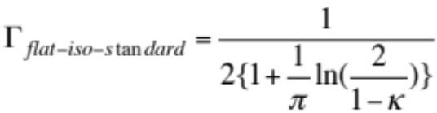 (1) with 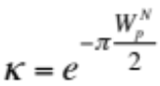 (2) where 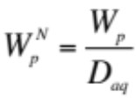 (3)
is the normalized wetted perimeter of the cross-section.
Step 2. The next step is to correct the previous value for the degree of penetration of the river, defined as 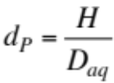 (4) based on the formula
(5)

Range of 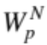 Range of 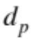 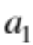 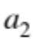
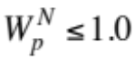 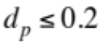 0.890 -2.430
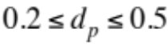 0.538 -0.387
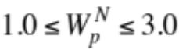 0.819 -1.340
0.672 -0.542
Note that in step 2 the value of always increases, though in practice it really does not increase that much because most rivers penetrate relatively little the aquifer. The more the river penetrates the aquifer, the easier for the seepage to occur.
Steps 3 and 4. The next steps are only necessary if the aquifer is anisotropic.
Step 3. Estimate the isotropic 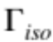 at the standard far distance for the case of anisotropy, which is:
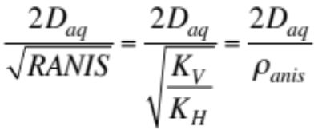 (6)
The excess normalized far distance for the still isotropic calculation of is: 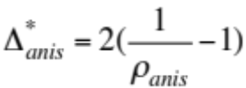 (7)
Correction for anisotropic far distance is:
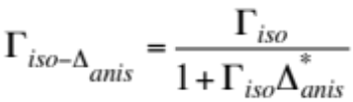 (8)
Note that in that step the value of always decreases. More resistance is added if only because more distance is added to the flow path.
Step 4. Next correct for the degree of anisotropy
Auxilliary variable: 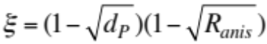 (9)
Next calculate the reduction factor: 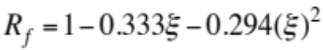 (10).
There is no reduction if the river fully penetrates the aquifer or in case of isotropy.
Apply the reduction factor : 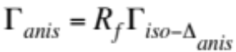 (11)
Now in case of anisotropy one has now calculated the value of but for a distance that is the standard anisotropic far distance. Again in that step the value of always decreases. More resistance is added.
Step 5. Whether the value of was calculated for step 2 (or steps 3 and 4 in case of anisotropy) the value of has to be corrected for the actual grid size for which G/4 is rarely going to be either the standard isotropic or anisotropic far distance. The choice of the grid size is based on various practical considerations and not based on the standard far distance used for the calculation of the SAFE dimensionless conductance.
The grid quarter size usually exceeds the standard anisotropic far distance. Then there is an excess far distance over the standard far distance: 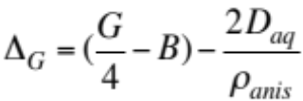 (12)
In case of isotropy of course 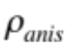is equal to 1 and 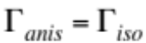
Correction: 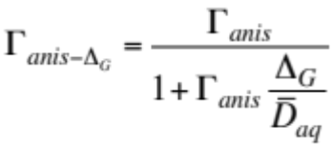 (13)
Whether in that step the value of decreases or increases depends upon the sign of 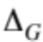.
The closer you get to the river bank the lower the head drop and to sustain the same steady flow the conductance must increase to compensate.
Step 6. The final correction is to account for the presence of a real clogging layer within the riverbed.
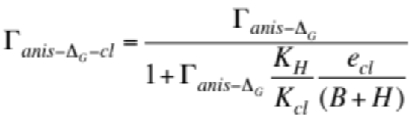 (14) where 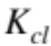 is the conductivity, 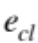is the thickness of the real clogging layer within the riverbed and 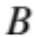 is the half river bottom width. In that step the value of always decreases. More resistance is added.

